To
The Security Officer
Technopark

16 June 2026
Sir/ Ma’am
Please permit our trainee ALBIN D SHIBU to enter Technopark campus 16 June 2026.

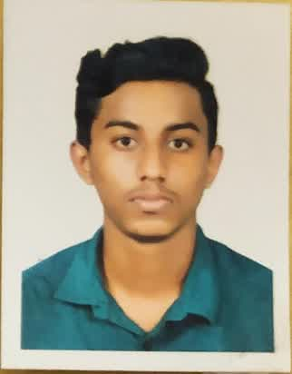

Note: For issuing new gate passes you must submit this back to the admin. In case you lose your gate pass there will be a fine of Rs 1000.
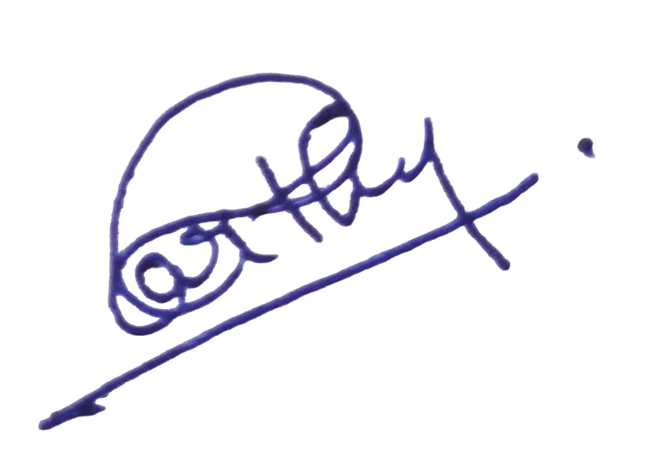
Aarthi A G
Contact No: +91-9072442200
HR Team – Srishti Innovative

